**ASESSMEN GAYA BELAJAR**

Nama : __________________________________

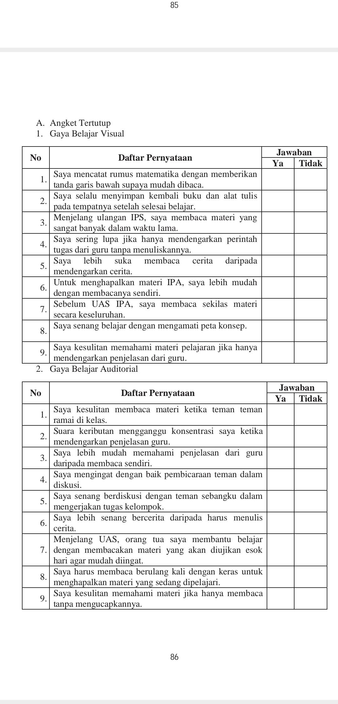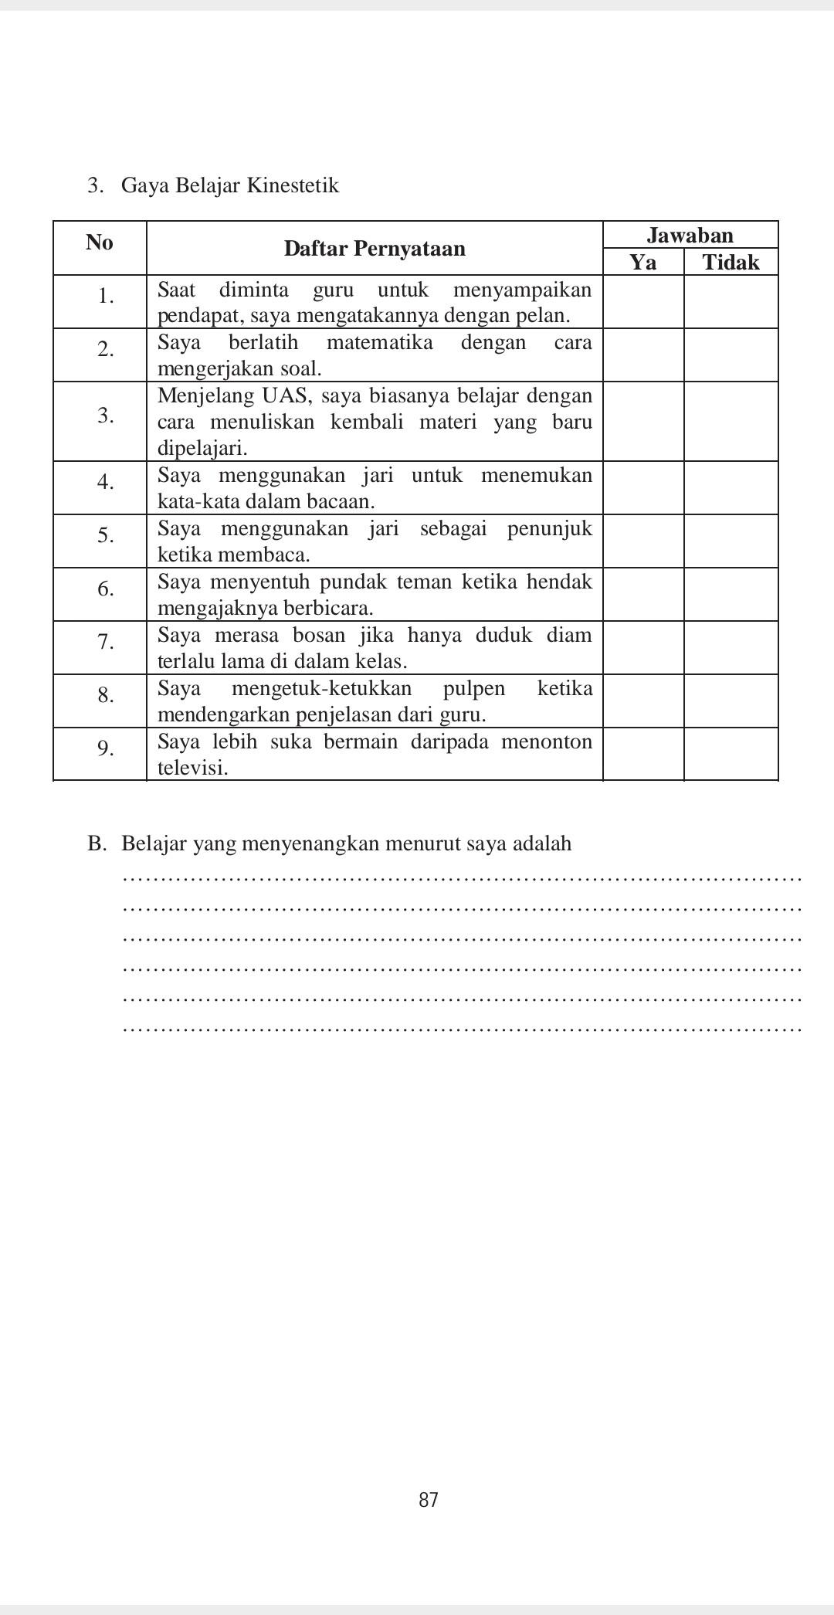Kelas : ________________________________